Alasdair Fraser/Natalie Haas 2017 workshop set (v. 2)
Length: just under 12 minutes

Soggy’s Jig 2X (2:00)
Straight in all. Rhythm on the first beat.
B part: m. 11, 15, 19, and 23- Play first 2 or 3 notes in first beat as a jig, then switch to duple time for the next 3 pairs of notes, so there’s a strong 1, 2, 3 at the end of these measures. Count “1 2 3, 1&, 2&, 3&“

2nd time through rhythm bouncier
Hold a long sustained “A”- some high, some open A, some the low A, while a few play the transition (see below) – 4 bars long, twice. *We need a few more folks on the riff below.

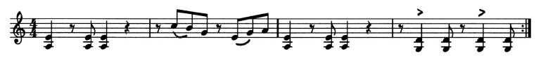

Temple Hill 3X (1:30)
1st time melody fiddlers start tune (A few strong players play the riff above for the entire A part, both times.) Everyone except rhythm and piano on the melody B part. B part riff TBA:
2nd every one in
3rd time –A part fiddles only; rhythm section back in for B part

Pea in the F Hole 2X (1:20)
Rhythm double bounce on A 4 times, fiddles come in

Eternal Friendship x2 (3:10)
AA - All
BB – all
AA – solo violin- Elinor
BB- All join
* Last phrase of B- starting with pickups, 5 bars. from end, quickly play softly, and build until high A on E, then decrease slightly to end for last 2 bars.
End: hold A (some hold high A on E string.) LONGER note

Along the Western Shores X2 (1:30)

End: hold E

St. Patrick’s An Dro X2 (2:00)
1st A – 1-3 Fiddles Only---Slow majestic tempo for the dance!
2nd A – All then BB – All
Play AA BB again, All in! Ending….

